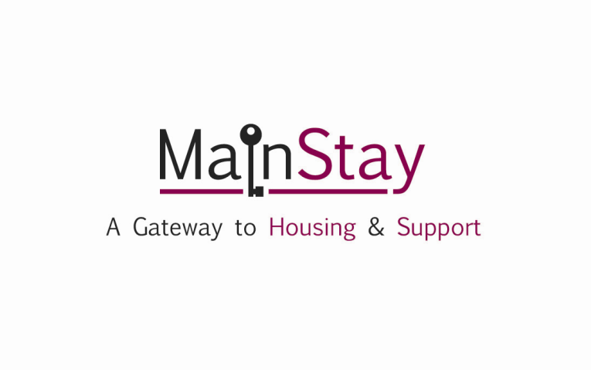

MAINSTAY REFERRAL FORM
DIRECT PRESENTATION |  |  |  |  |  | Date of referral
Reason for referral:- Please use the back sheet for more details about support needs.
Surname

Forename

Sex M F |  |  |  |  | Date of Birth
When would you like an assessment?- |  |  |  |  | Today Within the week  Specified date (Please Specify)
NI Number-

Pregnancy/Maternity - |  |  |  | Yes No Don’t Know Do not wish to disclose
Is English your first language? |  |  |  | Yes No  (If No please Specify)
Do you communicate in English? |  |  |  | Yes No
Contact details -  Preferred Contact Method  Tel No  Further Details |  |  |  | Further contact details-  Person to contact  Tel No  Agency Details (if appropriate)
Current Address (if applicable)  Address  Postcode  Local Authority Area  Liverpool □ Wirral □  Halton □ Sefton □  St Helens □ Knowsley □ Other □  If Other Please Specify |  |  |  | Type of accommodation currently occupied
 |  |  |  | - LA general  - Housing association general  - Private sector tenancy  - Private sector leasing  - Tied housing or rented with job  - Owner occupation (private)  - Owner occupation  - Supported housing  - Direct access hostel  - Women’s refuge  - Foyer  - Housing for older people  - Residential care home |  |  |  |  |  |  |  |  | - Hospital  - Prison  - Approved Probation hostel  - Children’s home/foster care B&B  - Short life housing Living with family  - Living with friends  - Mobile Home/Caravan  - Any other temp accom  - Home Office/Asylum  - Rough Sleeping  □ Other (Please specify below)
Next of Kin-  Name  Relationship |  |  |  | Address  Phone Number
Location of last settled accommodation  (if different from above) | Address  Postcode Local Authority Area
Disability | - None  - Mobility  - Visual Impairment  - Hearing Impairment  - Progressive disability/Chronic Illness (e.g MS, Cancer)  - Mental Health |  |  |  |  |  |  |  |  |  |  | - Learning Disability  - Autistic Spectrum Condition  - Does not wish to disclose  - Other (Please specify)
Economic Status | - Full-time work (24 hours or more per week)  - Part-time work (less than 24 hours per week)  - Govt training/Work Programme  - Job seeker  - Retired  - Not seeking work |  |  |  |  |  |  |  |  | - Full-time student  - Unable to work because of long term sickness or disability  - Other Adult (Please specify)
Immigration Status | - UK National  - EEA National  - Leave to Remain |  |  |  |  |  | - Asylum Seeker  - Study/Work visa
Ethnicity | White  - British  - Irish  - Other |  | Mixed  - White & Black Caribbean  - White & Black  - White & Asian  - Other |  |  |  |  | Asian or Asian British  - Indian  - Pakistani  - Bangladeshi  - Chinese  - Other |  |  | Black or Black British  - Caribbean  - African  - Other |  |  | Other ethnic group  - Arab  - Other ethnic group |  | Gypsy, Romany, Irish Traveller | Refused
Religion/Belief | - None  - Christian (all denominations)  - Buddhist  - Hindu |  |  |  |  |  |  |  | - Jewish  - Muslim  - Sikh |  |  |  |  |  | - Any other religion  - Not known  - Does not wish to disclose
Sexual orientation | - Heterosexual  - Gay Man |  |  |  |  |  |  |  | - Lesbian  - Bisexual |  |  |  |  |  | - Other  - Does not wish to disclose
Transgender | Yes No Don’t Know Do not wish to disclose
Are you Ex-Armed forces personnel? | Yes No Don’t Know Do not wish to disclose
By signing you are giving consent that the information in this form is correct and can be shared with services within the MainStay.

Signed:

Date:

PLEASE DESCRIBE CURRENT SUPPORT NEEDS BELOW:-

PLEASE DESCRIBE CURRENT SUPPORT NEEDS BELOW:-

